Tectonic Plates
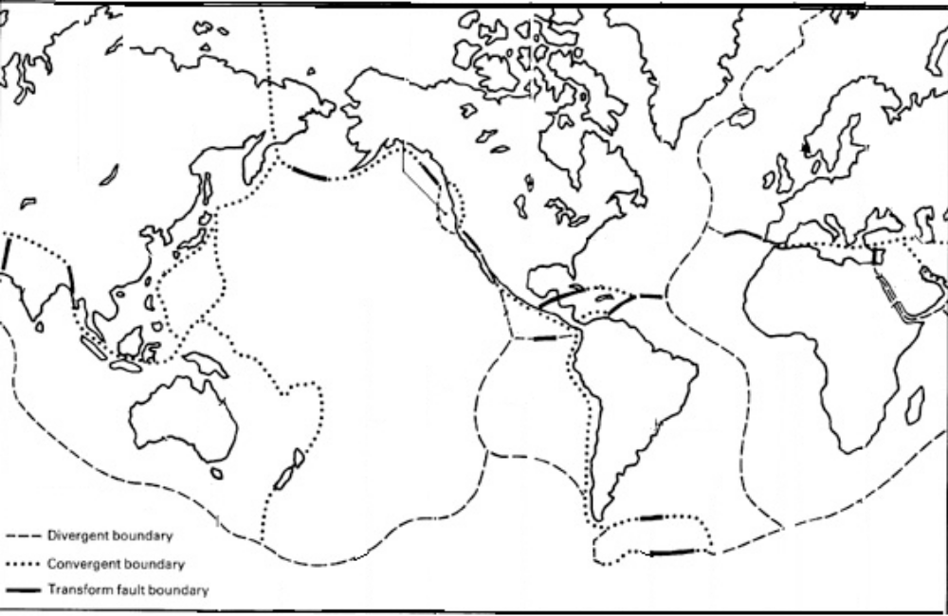
7 Major Plates:
North America Plate
South American Plate
Pacific Plate
African Plate
Eurasian Plate
Indo-Australian Plate
Antarctic Plate
8 Minor Plates:
1. Nazca Plate
2. Caribbean Plate
3. Cocos Plate
4. Juan De Fuca Plate
5. Arabian Plate
6. Indian Plate
7. Philippine Plate
8. Scotia Plate

Directions: Label and colour the 7 major plates. Just number (don't colour!) the minor plates. Put in arrows to show the direction the plates are moving in, then answer the questions on the back of this page.

1. List the seven major plates.
a.
b.
c.
d.
e.
f.
g.

2. List eight minor plates.
a.
b.
c.
d.
e.
f.
g.
h.

3. On what plate is Australia?

4. Find the west coast of North America. Which 2 major plates is it in?

5. What type of boundary is located there?

6. What plate matches almost perfectly with the Ring of Fire, where most of the world’s earthquakes and volcanoes occur?

7. What plates correspond to the Mid-Atlantic Ridge?
a.
b.
c.
d.

8. List two continents whose edges are not all on plate boundaries.
a.
b.

9. Where are most plate boundaries?

10. What major plate is the largest?

11. What minor plate is the smallest?

